Purchasing BBO money

Desktop computer or Laptop
On a desktop computer or laptop you will see the below screen:

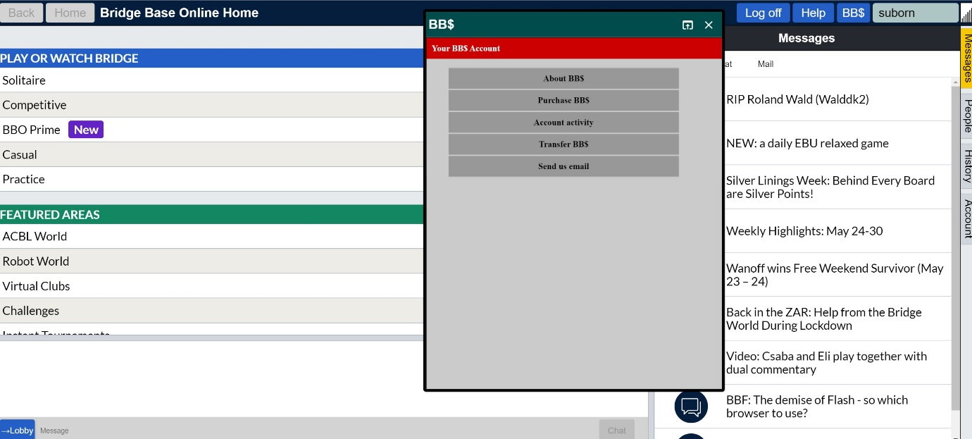
Press on the blue button ‘BB$’ in the top right hand of the screen
You can purchase BB money or check on your account balance
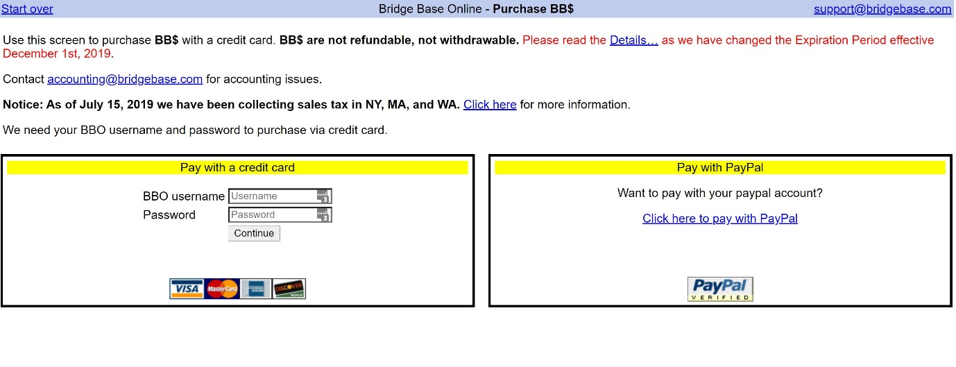

iPad or iphone
If you are on an ipad you will need to click on the ‘Shop’ button at the bottom right of your screen. It has a picture of a shopping cart.
Your BBO balance will show in a yellow box in the bottom right of your screen when you initially login or first enter the shop.
